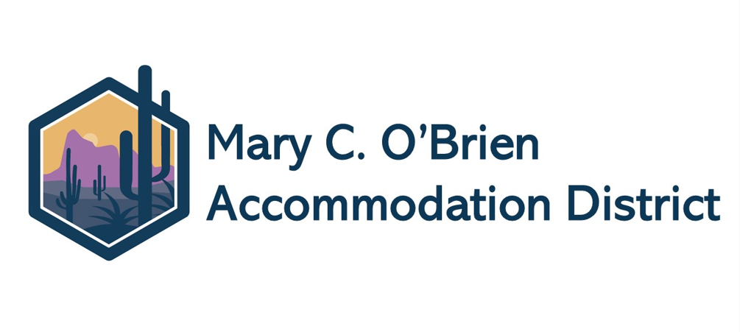BOARD MEETING SCHEDULE
2025-2026
Date | School | Location | Time
07/14/2025 | VILLA | BATTS – SPECIAL MTG. | 3 p.m.
08/28/2025 | MCOB | PD Training Room | 9 a.m.
9/25/2025 | VILLA | BATTS | 11 a.m.
10/30/2025 | MCOB | PD Training Room | 11 a.m.
12/18/2025 | VILLA | BATTS | 11 a.m.
1/29/2026 | MCOB | PD Training Room | 11 a.m.
2/26/2026 | VILLA | BATTS | 11 a.m.
3/26/2026 | MCOB | PD Training Room | 11 a.m.
5/28/2026 | VILLA | BATTS | 11 a.m.
6/25/26 | TBD | RETREAT | 9 a.m.

